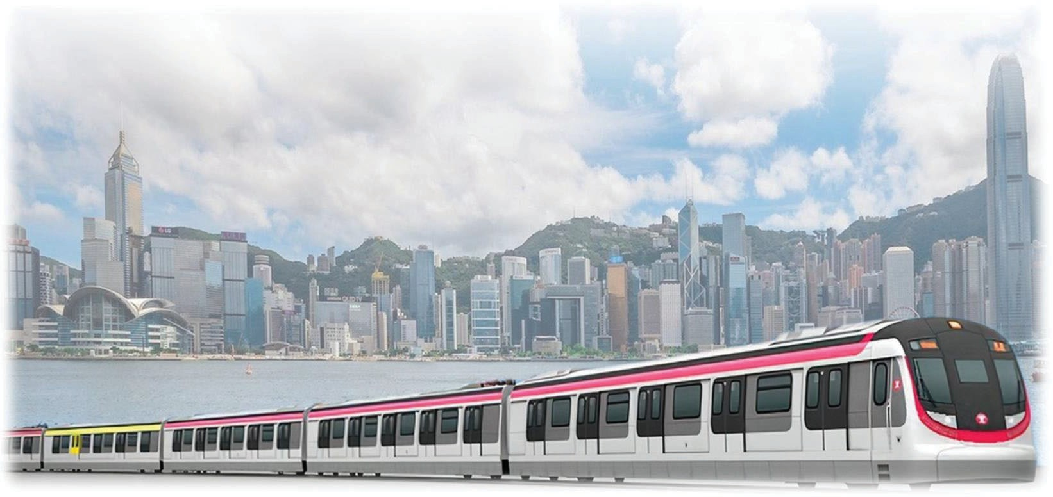



TUEN MUN SOUTH EXTENSION

**PROJECT EXECUTION PLAN [*TME/PEP-001/A2*]**

**Document Change Record**

|  |  |  |  |
| --- | --- | --- | --- |
| Revision | Issue Date | Page No(s). | Major Changes |
| A1 | 11 December 2023 |  | 1st Issue |
| A2 | 26 January 2024 |  | Document Reference Updated |
|  |  |  |  |
|  |  |  |  |
|  |  |  |  |
|  |  |  |  |

**Document Approval Record**

|  |  |  |  |
| --- | --- | --- | --- |
|  | Job Title | Name | Signature |
| ORIGINATOR | Chief Construction Manager –  TME Civil | Jimmy Poon |  |
| CONTROLLER | Project Manager – TME & HSK | Walter Lam |  |
| REVIEWER | Chief Project Quality Manager | Antony Smith |  |
| APPROVER | General Manager –  E&M Construction | Tim Leung |  |

© 2024 MTR Corporation Limited.

All rights including, without limitation, intellectual property rights in and to this document and any information contained in this document are proprietary and are solely and absolutely owned by MTR Corporation Limited. The document and any information contained in the document are strictly confidential and must not be used, disclosed, transmitted, copied, printed or otherwise disseminated without the prior written consent of MTR Corporation Limited. Violators will be subject to legal sanctions such as an injunction order and will be held liable for any damages, losses, costs and expenses incurred by MTR Corporation Limited.

**CONTENTS**

1. Introduction 5
   1. Scope 5
   2. Objectives 5
   3. Ownership and Application 6
   4. Interfaces 6
2. Project Overview 8
   1. Project Objectives 8
   2. Project Scope 8
   3. Key Project Milestones 9
   4. Project Stage Overview 9
   5. Project Agreement 10
   6. Project Procurement Strategies 10
   7. Project Organization 11
   8. Project Definition Documents (PDDs) 11
3. Project Delivery Approach 13
   1. Implementation of PIMS 13
   2. Project Management, Coordination and Interface Management 13
   3. Project Governance 14
   4. Occupational Safety & Health 14
   5. Quality Management 15
   6. Environmental Management 15
   7. Stakeholder Engagement 15
   8. Project Delivery Risk Management 16
   9. Programme Management 16
   10. Design Management 16
   11. Construction Management, Testing and Commissioning 17
   12. Handover of Completed Works 17
   13. Statutory Compliance 17
   14. Information Management 18
   15. Commercial Management 18
4. External Monitoring and Control 19
   1. Project Agreement 19

Appendix 1: Project Execution Plan Terms and Roles 20

Appendix 2: Abbreviations 21

Appendix 3: Reference Documents 22

Appendix 4: Summary list of Major Contracts 23

Appendix 5: Organisation Chart 24

Appendix 6: Project Summary Interfaces Register 25

Appendix 7: Site Supervision Team Arrangement 26

1. Introduction

# Scope

* + 1. This Project Execution Plan (PEP) applies to Tuen Mun South Extension (TME), and all personnel of MTR Corporation Limited (MTRCL) involved in managing the project.
    2. This PEP has been developed for construction stage commencing Q4 2023 and shall be further reviewed as and when necessary.
    3. This PEP does not include Hung Shui Kiu Station Works.

# Objectives

* + 1. This PEP is the principal management tool for the General Manager (GM) / Project Manager (PM) to manage the project. It has been developed in accordance with Project Management Procedure for developing Project Execution Plan and will be reviewed and updated half yearly. This frequency can be extended to yearly at the discretion of the GM, but as a minimum the PEP should be updated and re-issued at the commencement of each project lifecycle stage.
    2. The purpose of this PEP is to:
       - Provide a summary of the project scope, objectives, key milestones and organisation as a reference point for all personnel;
       - Document key project activities, assumptions, risks and interfaces relevant to the specific project stage;
       - Set out the how the General Manager (GM) /Project Manager (PM) will address the key management themes addressed in Project Management Procedure: leadership, partnering, team, interface coordination, management of change, communications, etc.
       - Define how PIMS and wider MTRCL requirements for management of TME are to be implemented, and the objectives of the Project Integrated Management System Policy achieved; and
       - Summarise any specific project strategies and approaches that have been agreed, with references to related project specific management plans that have been developed where appropriate.

# Ownership and Application

* + 1. This PEP is owned and controlled by the Project Manager, and they are accountable for its ongoing maintenance to reflect the Project Management requirements relevant to each stage of the project lifecycle.
    2. Responsibility for application of this PEP is delegated by the General Manager (GM) to the Project Manager assigned to TME.

# Interfaces

* + 1. This section outlines who needs to be engaged with in relation to Project Management requirements for TME*.*
    2. The main internal interfaces in relation to Project Management processes for TME include, but are not limited to the following:

|  |  |
| --- | --- |
| **WHO** | **HOW and WHY** |
| **Capital Works** | Manages and reviews development of Project Definition |
| **Technical** | Documents (PDDs) for use on Capital Works projects and defines |
| **Management** | the associated technical audit requirements to verify compliance |
| **Committee** | of individual Projects with the appropriate PDDs. |
| **(CWTMC)** |  |
| **Project** | Ensures the project is delivered according to the PDD |
| **Management** | requirements and within the specific time and budget through the |
| **Team** | day-to-day First Line of Defense (“1LoD”) activities. |
| **Enabling Functions** | Includes Capital Works Business Unit (CWBU) Technical, PMO, Commercial Management, Chief of Staff and Safety Management Departments.  Provides support to Project Management Team to ensure the project is delivered according to the PDD requirements to expect quality level and within the specific time and budget through the day-to-day support, review, and audit activities.  Develops best practices and processes and provide governance on their respective expert areas.  Specific resources may be allocated to support the PMT as required by the project scope. |
| **Hong Kong Property and Hong Kong Transport Business Unit** | To manage and coordinate the interfaces between CWBU, PBU and HKTS scope works and operations.  Provide support to the PMT to ensure the project is delivered to expected quality level within the specific time and budget through day-to-day and regular meeting forums. |
|  | To provide direction and prioritization to the PMT at interfaces through the scheduled regular TME Steering Committee meeting. |

* + 1. The main external interfaces in relation to Project Management processes for TME include, but are not limited to the following:

|  |  |
| --- | --- |
| **WHO** | **HOW and WHY** |
| **Consultants,** | To provide services as contracted to deliver the project in |
| **Contractors,** | accordance with the Project Definition Documents. And their |
| **Suppliers and** | respective scope of services. |
| **Vendors** |  |
| **Railway Development Office** | To facilitate the monitoring and control performed by Government to oversee the delivery performance of the TME project parts related to the Project Agreement. |
|  | Provide support and oversee the project delivery to expected quality level within the specific time through regular supervision and communication platforms specified within the Project Agreement, including Project Coordination Subcommittee, Project Safety Review Committee, Project Supervision Committee and  Project Board. |
| **Drainage** | DSD is a Government department overseeing the works in Tuen |
| **Services** | Mun River Channel (TMRC) where a large portion of TME project |
| **Department** | works would be undertaken. DSD is simultaneously also |
| **(DSD)** | undertaking drainage improvement works and also routine |
|  | maintenance activities in the Channel during TME construction |
|  | period. Close management of the interfaces with DSD is required. |
| **Leisure And Cultural Services Department (LCSD)** | LCSD is a Government department managing and overseeing the operations of the existing Tuen Mun Swimming Pool (TMSP), where the critical path of the TME project lies. TME project would undertake reprovisioning of the TMSP in a new location and a close coordination and interfaces in terms of the requirement management and also transition management from existing TMSP to new TMSP is required. |
|  | Apart from the reprovisioning of the TMSP, in initial phase of the construction, TME construction would also be undertaken in close proximity to existing TMSP and also within some of the TMSP  areas, for which, close liaison is required. |

1. Project Overview

# Project Objectives

* + 1. The detailed Project Objectives for the TME are contained within the Project Objectives for the Tuen Mun South Extension (TME) document, reference TME-PO- GM(PCENGG)-PDD-100001A1. The primary objectives of the TME project are summarized below:
       - To provide a new mass transit railway service to the existing and future communities in Tuen Mun south area and Area 16 to encourage greater use of the railway system, by enhancing coverage, and thereby improve mobility and transport connections to the existing Light Rail service, alleviate traffic congestion, reduce road-generated noise and improve air quality;
       - Encourage further economic and urban development and renewal in the New Territories West; and
       - To complement the development of the long-term railway corridor.

# Project Scope

* + 1. The design, construction, completion, testing and commissioning of the A16 Station (A16) and Tuen Mun South Station (TMS). The scope covers:
       - An elevated extension, of approximately 2.4 km long, southwards from the existing Tuen Mun (TUM) Station track overrun to the Tuen Mun south area, with modifications to the ends of the existing viaduct and track overrun;
       - A new elevated terminus station, namely Tuen Mun South (TMS) Station, over Wu King Road;
       - A new station, currently named A16, with elevated platforms and an at-grade

concourse, all located at Tuen Mun Area 16 (hereafter referred to as “Area 16”).

* + - * A new stabling track at existing Pat Heung Depot stabling area;
      * Modification of passenger information and signage at TUM to suit the change in passenger movements after the opening of the TME; and
      * Reprovisioning of Tuen Mun Swimming Pool away from Area 16, the Tuen Mun Road Safety Town, and a Highways Department (HyD) footbridge across Wu King Road.

# Key Project Milestones

* + 1. The key project milestones identify significant achievements throughout the duration of the works, including; works area access, commencement of significant activities, phased handover or completion of works at key interfaces, interdependencies across portfolio projects, staged and final completion. The key project milestones will be identified and monitored in the master programme.

# Project Stage Overview

* + 1. The current project stage is the Construction Stage. The following is a summary of key activities for the construction stage of the project. These key activities are identified and monitored in the Project Master Programme:
       - Completion of all works for GREEN@TUEN MUN and take over by EPD.
       - Completion of the reprovisioning of Tuen Mun Swimming Pool.
       - Completion of new stabling track at existing Pat Heung Depot stabling area.
       - Completion of viaducts and stations for trackwork degree 1.
       - Completion of works at A16 Station, TMS Station and viaducts to be ready for OHL energization.
       - FSD and all statutory inspections complete for Safe and Sound.
       - Completion of the Works.
    2. The following is a summary of key interfaces / dependencies for the construction stage of the project:
       - Re-provision of GREEN@TUEN MUN and Tuen Mun Swimming Pool for construction of A16 Station.
       - Completion of overrun track modification in existing Tuen Mun Station.
       - Completion of A16, TMS and viaducts for trial operation.
    3. The following is a summary of the project delivery risks at the Construction Stage identified for this project. The project delivery risks are reviewed and managed as described in Section 3.8.
       - Accidental damage of railway facilities impacting TML operations.
       - Accidental damage of settlement of facilities affecting operations and other parties.
       - Delayed handover of work sites to TME project from government departments.
       - Delayed statutory approvals for works over Tuen Mun River Channel.
    4. The following is a summary of Key Stakeholders for the construction stage of the project.
       - Hong Kong Transport Services (HKTS) are the operator for the existing TML railway adjacent TUM works sites.
       - Property Business Unit (PBU) constructing residential and commercial developments adjacent to A16 subsequent to completion of works.
       - Environmental Protection Department (EPD) will take over of the re-provisioned GREEN@TUEN MUN.
       - Leisure and Cultural Service Department (LCSD) will takeover the re-provisioned New Tuen Mun Swimming Pool.
       - Railway Development Office (RDO) will undertake monitoring and checking of the TME construction in accordance with the Project Agreement.
       - Drainage Services Department (DSD) will review and approve the drainage impacts of TME to the existing Tuen Mun River Channel.
       - CEDD, DSD, ArchSD and HyD concurrent contracts, corresponding sites interfacing with alignment of TMS project.

# Project Agreement

* + 1. The Project Agreement for the financing, design, construction, pre-operation, operation and maintenance of the Tuen Mun South Extension had been signed between the HKSAR and MTRCL on 5 September 2023.

# Project Procurement Strategies

* + 1. Advance works: To maximise programme certainty, advance works packages have been identified and commenced prior to the Construction Stage, as summarised below:
       - Underground utilities diversion works and site preparation works at existing Tuen Mun Golf Centre.
    2. Main works contracts: The main works contracts will be procured and packaged as described below. A list of major contracts is provided in Appendix 4.

**Contract 1500 – TME Stations, Viaducts and River Crossing**; will be procured under NEC4 Engineering and Construction Contract – Option C: Target cost contract with activity schedule, and will be procured as a design-and-build contract. This contract will include civil works for A16 Station and viaducts connecting TUM and TMS; and building services (BS) and ABWF works for the A16 Station and TMS Station under a Design and Build arrangement. Procurement of the works utilized a two-stage tender process. This approach which will enable a flexible approach to the management of risks and opportunities, promote innovation and collaboration and incentivize cost reduction and value for money. New technologies and initiatives including Modular Integrated Construction (MIC), Design for Manufacture

Assembly (DfMA), off-site fabrication and digitalized project management will be promoted.

* + - * **Contract 1503 – New Tuen Mun Swimming Pool**; will be procured under NEC4 Engineering and Construction Contract – Option A: Priced contract with activity schedule. This contract will include civil works for New Tuen Mun Swimming Pool including building services (BS) and ABWF works under an Engineer’s Detailed Design arrangement.
      * **Contract 1504 – Additional Stabling Facilities for Tuen Ma Line at Pat Heung Depot;** will be procured under NEC4 Engineering and Construction Contract – Option A: Priced contract with activity schedule, and will be procured as a design- and-build contract. This contract will include civil works for new Signalling Equipment Room, associated plant rooms and stabling tracks including building services (BS) and ABWF works under a Design & Build arrangement.

# Project Organization

* + 1. The General Manager (GM – New Territories (Projects)) will oversee the performance of the TME project, reporting to the Capital Works Director (CWD). The General Manager E&M (GM – E&M Con) will oversee the systemwide E&M, reporting to the CWD. The TME specific PMT will be led by the Project Manager (PM – TME & HSK), reporting to the GM – New Territories (Projects).
    2. The PMT will comprise project specific resources, supplemented by shared New Territories portfolio staff and support function staff. The organisation chart for the TME PMT is provided in Appendix 5.

# Project Definition Documents (PDDs)

* + 1. The Project Definition Documents at the commencement of the Construction Stage include those documents summarized below:
       - Project Objectives
       - Project Requirements
       - Project Agreement
       - Project Cost Estimate
       - Project Programme
       - Detailed Design
       - Railway / Property Interface Control Document
       - Environmental Impact Assessment and Environmental Permit
       - Buildings Department Instrument of Exemption
       - General System Assurance Requirements
       - Functional Requirements Manual
       - Design Standards Manual
       - Fire Safety Strategy Documents
       - New Works Standard Details
       - General Specifications
       - Materials & Workmanship Specifications
       - Particular Specifications

1. Project Delivery Approach

# Implementation of PIMS

* + 1. The TME project shall implement PIMS to ensure that all work is completed in accordance with the specified criteria in a consistent and controlled manner to achieve the CWBU objectives set out in the PIMS Policy.

# Project Management, Coordination and Interface Management

* + 1. The project will be managed in accordance with the Project Management Procedure – PIMS/PJM/PRO-001 and the Construction Management Procedure – PIMS/CON/PRO-001.
    2. Project resources will be recruited via the Human Resources department to suit project needs and in accordance with agreed staff forecast. Onboarding of new team members will include the MTR and project specific induction processes. Team and individual competency will be assessed annually, with training needs identified.
    3. A behavioural specialist has been engaged to promoted collaborative behaviours and an effective working environment. The specialist will conduct evaluations of team behaviours and collaborative arrangements for the PMT, support functions and stakeholders periodically.
    4. A Project Charter will be developed identifying the key behaviours for project success. The Project Charter will be developed collaboratively with internal and external parties and a Behavioural Specialist.
    5. Team building events and behavioural assessments will be undertaken periodically in conjunction with the Behavioural Specialist for MTR, Contractor, Consultant and Government staff; to promote behaviours in accordance with the Project Charter.
    6. The performance of the project will be monitored through the implementation and monitoring of Key Performance Indicators (KPI’s). These KPI’s will be updated and reported monthly.
    7. Coordination of the project will be undertaken principally through the project specific meetings, between PMT, Consultants, Contractors and Stakeholders. A project specific meeting schedule or calendar will be established and reviewed periodically.
    8. Interface management will be in accordance with the Construction Management Procedure – PIMS/CON/PRO-001. Identified requirements are documented in the Project Summary Interface Register, refer to Appendix 6.

# Project Governance

* + 1. The focus of the Project Governance Assurance during the construction stage includes oversight of project scope, progress, budget control, quality and safety. The project governance will be in accordance with the Project Governance Procedure – PIMS/GOV/PRO-001.
    2. A Project Assurance Plan will be maintained throughout the Construction Stage and reviewed periodically.
    3. To oversee the project a Project Steering Committee will be established at the commencement of the Construction Stage, with representatives from the key stakeholders including HKTS, PBU and CWBU. Coordination and other issues that cannot be resolved at project level will be elevated to the Project Steering committee for decision.
    4. The key Governance decision points for the project include:
       - The end of the Construction Stage and approval to progress to the Testing and Commissioning Stage. This will be decided by the Commission Panel.

# Occupational Safety & Health

* + 1. The safety and welfare of all persons on or involved on the delivery of the project is paramount. The project safety will be principally managed in accordance with the Occupational Safety and Health Management Procedure – PIMS/OSH/PRO-001 and Health and Safety Management Manual – D/PROJ/GEN/H&S/MAN/001.
    2. To address construction safety risk and hazards, a Safety Management Plan is established and maintained for the duration of the project. The safety Management Plan is available on iShare.
    3. To address project specific risk and hazards, a project specific safety programme shall be established annually, targeted to address identified project specific safety risks. The project specific programme will include project specific safety goals, which will be aligned with the CWBU safety goals.
    4. The project safety performance will be monitored with the agreed safety KPI’s and reported monthly in the Monthly Project Progress Report and Project Agreement Report.

# Quality Management

* + 1. The quality management of the works will be undertaken in accordance with the Project Quality Assurance Procedure – PIMS/PQA/PRO-001.
    2. A project specific Project Quality Plan shall be maintained for planning, implementation and reviewing the quality performance of the project. The project specific Project Quality Plan is reference TME/PQP/001.
    3. Quality performance shall be monitored with the agreed quality KPI’s and reported

monthly in the Monthly Project Progress Report and the Project Agreement Report.

# Environmental Management

* + 1. The environmental management of the works will be in accordance with the Environmental Management Procedure – PIMS/ENV/PRO-001.
    2. An Environmental Management Plan (EMP) will be developed by the Contractors for the Project explaining how the environmental management system of the project will be implemented, in order to ensure compliance with the approved TME EIA report, TME Environmental Permit (EP) and Contract requirements.
    3. Each Contractor will prepare their own contract specific EMP. The Contractor shall regularly review any significant changes in the approved EMP and update the EMP as necessary.
    4. Environmental Monitoring and Audit (EM&A) programme will be implemented in accordance with the approved TME EM&A Manual under Environmental Impact Assessment Ordinance Cap. 499 (EIAO) to ensure compliance with the recommendations in the approved TME EIA report.
    5. Environmental KPI’s will be reported in the Monthly Project Progress Report and the

Project Agreement Report.

# Stakeholder Engagement

* + 1. A two-tier management structure is adopted for managing stakeholder engagement in CWBU. The Stakeholder Engagement (SE) programmes for all projects and the CWBU will be overseen by the Capital Works Stakeholder Engagement Committee (CWSEC).
    2. The Stakeholder Engagement Plan (SEP) is the principal management tool for managing the SE process of the project, ref TUE/STE/SEP-001/A1. The SEP sets out the key objective to capture and prioritize appropriate actions and activities to engage the stakeholders.
    3. Stakeholder related KPI’s will be reported in the Monthly Project Progress Report and

the Project Agreement Report.

# Project Delivery Risk Management

* + 1. Project delivery risks will be managed in accordance with the Project Delivery Risk Management procedure – PIMS/RSK/PRO-001 and the NEC4 Early Warning system, for contracts procured using the NEC4 form of contract.
    2. Project risk management strategy will be defined within the latest project specific Project Delivery Risk Management Plan.
    3. Project-wide risks will be identified and recorded on the Project Delivery Risk Register – PIMS/RSK/IFT-001. This register will be maintained with current project risks during monthly project risk review meetings.
    4. In addition, contracts under NEC4 Engineering and Construction Contract will identify contract specific risks at Early Warning meetings. These risks will be managed following NEC4 guidelines for Early Warning management.
    5. Proactive reporting of identified risks and ‘early warnings’ will be reported to RDO, for risks including public and railway safety, in accordance with the Project Agreement. These risks will be reported quarterly in the Project Agreement Report.

# Programme Management

* + 1. The project programme will be managed in accordance with the Programme Management Procedure – PIMS/PGM/PRO-001.
    2. The Project Master Programme (PMP) will be developed from the Integrated Master Programme (IMP), with critical interdependencies identified and monitored.

Programme related KPI’s will be reported in the Monthly Project Progress Report and

Project Agreement Report.

# Design Management

* + 1. The project design will be managed in accordance with the Design Management Procedure – PIMS/DEM/PRO-001.
    2. The permanent works design will be undertaken by the respective contractors and approved by MTR.
    3. Temporary works, and aspects of the building services and ABWF design will be undertaken by the Contractor. These designs will be coordinated with the Consultant and approved by MTR.
    4. As far as is practicable, the design will be undertaken using building information modelling, with 2D information generated from 3D federated models. Model federation will be managed by the Contractor and defined within the approved BIM Execution Plan.
    5. Design related KPI’s will be reported in the Monthly Project Progress Report and the

Project Agreement Report.

# Construction Management, Testing and Commissioning

* + 1. The project construction management will be in accordance with the Construction Management Procedure – PIMS/CON/PRO-001.
    2. The project testing and commissioning will be in accordance with the Testing and Commissioning Procedure – PIMS/TNC/PRO-001.
    3. Site supervision of construction activities of works under the IoE and Buildings Ordinance will be inspected and supervised by the Project AP, RSE and RGE, provided by the respective civil contracts. The AP, RSE and RGE will manage their respective TCP teams to conduct inspections in accordance with the Buildings Department Code of Practice for Site Supervision of Buildings.
    4. The MTR site supervision team will endure compliance with MTR quality and safety processes in accordance with PIMS and the approved Project Management Plan. The MTR site supervision team will assist in the coordination of site activities between interfacing Contractors, HKTS and Railway Protection teams.
    5. The working arrangement and allocation of responsibilities between MTR supervision team and the AP, RSE and RGE teams in shown in Appendix 7.

# Handover of Completed Works

* + 1. The handover of completed works will be in accordance with the Handover of Completed Works Procedure – PIMS/HCW/RPO-001.
    2. The first major handover of completed works will be the re-provisioned GREEN@TUEN MUN.
    3. The second major area for handover of completed works will be the re-provisioned New Tuen Mun Swimming Pool.
    4. The final major area for handover will be at the Completion of the Works for A16 and TMS station to HKTS.

# Statutory Compliance

* + 1. The statutory compliance of the works will be carried out in accordance with the Statutory Compliance Procedure.
    2. The project works are divided between those subject to Buildings Ordinance (BO) and those subject to the approved Instrument of Exemption (IoE)/ the Statement of Intent (SOI). The works supporting future topside development are subject to the BO, and include; the foundations, pile caps and associated structures used to support future property deck. The modification works of Tuen Mun Station for line extension is subject to SOI. The works associated without future topside development, are subject to the IoE, and include; the stations.
    3. The works will be constructed in accordance with approved design submitted either for full approval under the BO in cases where the works are not exempted from the BO; or acknowledged under consultation under the IoE in case where the works are exempted from the BO.
    4. The works will be carried out in compliance with the requirements stipulated under other submissions or inspections made with regard to and including the Station and Transport Integration Committee (STIC), Safety and Security Coordinating Committee (SSCC) and the Trackside Safety and Security Committee (TSSC), RB-EMSD, FSD and other regulatory bodies.
    5. The MTR staff employed on the project will be supplemented with AP/RSE/RGE inspectorate teams to undertake independent works inspections to ensure compliance with approved design and statutory requirements.

# Information Management

* + 1. The project information (BIM, drawings, specifications, reports etc) shall be managed using a Common Data Environment (CDE), allowing efficient issue, storage and retrieval of materials. Common Data Environment (CDE) will serve as a means for sharing information within MTR, Contractors, Consultants and as platform for sharing information to the Government.
    2. Commercial projects information shall be managed using CEMAR. This system will be used to administer the NEC4 contract.

# Commercial Management

* + 1. The commercial management will be undertaken in accordance with the Commercial Management and Procurement and Supply Chain procedure.
    2. The cost control of the construction phase will be carried out in accordance with the Cost Control Procedure for the Project Construction Phase.

1. External Monitoring and Control

# Project Agreement

* + 1. The TME project shall implement specific arrangements as set out within the Project Agreement, to support the monitoring and control undertaken by RDO.

Appendix 1: Project Execution Plan Terms and Roles

The following terms and roles are used across this Project Execution Plan:

# Project Execution Plan terms:

|  |  |
| --- | --- |
| **Term** | **Description** |
| **Project Definition Documents (PDDs)** | A hierarchy of documents which defines the performance requirements and objectives of a particular project. |
|  |  |
|  |  |
|  |  |
|  |  |
|  |  |
|  |  |

**Project Execution Plan roles:**

|  |  |
| --- | --- |
| **Role** | **Description** |
|  |  |
|  |  |
|  |  |
|  |  |
|  |  |
|  |  |
|  |  |

Appendix 2: Abbreviations

|  |  |
| --- | --- |
| **Abbreviation** | **Definition** |
|  |  |
| **CCM** | Chief Construction Manager |
| **CDM** | Chief Design Manager |
| **CPQM** | Chief Project Quality Manager |
| **CWTMC** | Capital Works Technical Management Committee |
| **GM** | General Manager |
| **IoE** | Instrument of Exemption |
| **PDD** | Project Definition Documents |
| **PM** | Project Manager |
| **PMT** | Project Management Team |
|  |  |
|  |  |
|  |  |
|  |  |
|  |  |
|  |  |
|  |  |
|  |  |
|  |  |
|  |  |
|  |  |

Appendix 3: Reference Documents

**PIMS References:**

**Policy:**

* PIMS/POL-001 Project Integrated Management System (PIMS) Policy

**Procedures:**

* PIMS/CON/PRO-001 Construction Management Procedure
* PIMS/DEM/PRO-001 Design Management Procedure
* PIMS/ENV/PRO-001 Environmental Management Procedure
* PIMS/GOV/PRO-001 Project Governance Procedure
* PIMS/HCW/PRO-001 Handover of Completed Works Procedure
* PIMS/LAN/PRO-001 Land Administration Procedure
* PIMS/OSH/PRO-001 Occupational Safety & Health Procedure
* PIMS/PGM/PRO-001 Programme Management Procedure
* PIMS/PIM/PRO-001 Project Information Management Procedure
* PIMS/PJM/PRO-001 Project Management Procedure
* PIMS/PRI/PRO-001 PIMS Management Review & Improvement Procedure
* PIMS/PQA/PRO-001 Project Quality Management Procedure
* PIMS/RSK/PRO-001 Project Delivery Risk Management Procedure
* PIMS/STC/PRO-001 Statutory Compliance Procedure
* PIMS/STE/PRO-001 Stakeholder Engagement Procedure
* PIMS/TNC/PRO-001 Testing & Commissioning Management Procedure

**Project Document References:**

* Project Management Plan
* Project Design Management Plan
* Project Quality Plan
* Project Environmental Management Plan
* Project Risk Management Plan
* Project Assurance Plan
* Project Stakeholder Engagement Plan
* Project Design Management and Assurance Plan
* Project Safety Management Plan

Appendix 4: Summary list of Major Contracts

|  |  |
| --- | --- |
| **Contract** | **Title** |
| 1500 | Tuen Mun South Extension: TME Stations, Viaducts and River Crossing |
| 1503 | Tuen Mun South Extension: New Tuen Mun Swimming Pool |
| 1504 | Additional Stabling Facilities for Tuen Ma Line at Pat Heung Depot |

Appendix 5: Organisation Chart

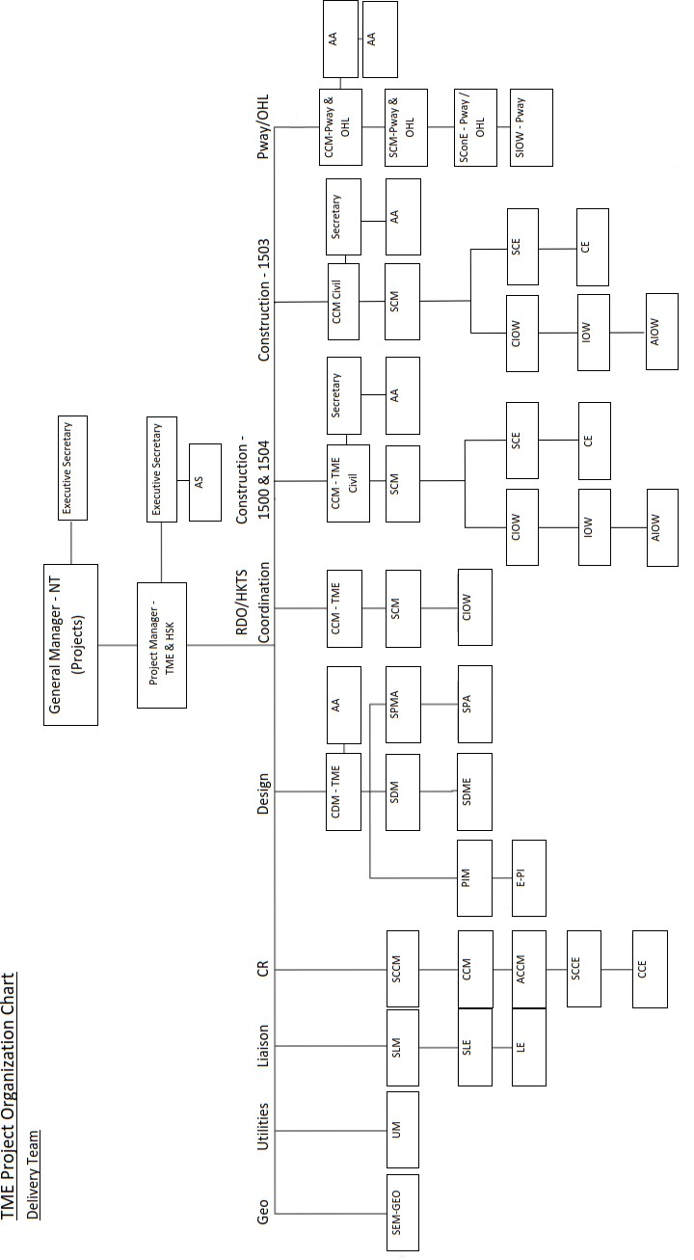

Appendix 6: Project Summary Interfaces Register

|  |  |
| --- | --- |
| **Ref.** | **Definition** |
| 1. | Hong Kong Transport Service Business Unit – Operation Interface works |
| 2. | Hong Kong Property Business Unit – Subsequent Private Development in Area 16 |
| 3. | Environmental Protection Department (EPD) taking over of the re-provisioned GREEN@TUEN MUN |
| 4. | Leisure and Cultural Service Department (LCSD) taking over of the re- provisioned New Tuen Mun Swimming Pool |
| 5. | Railway Development Office (RDO) undertaking monitoring and checking of the TME construction in accordance with the Project Agreement |
| 6. | CEDD, DSD, ArchSD and HyD concurrent contracts, corresponding sites interfacing with alignment of TME project |

Appendix 7: Site Supervision Team Arrangement

